Good-Bye to Xochimilco

By ReadWorks
On a Sunday afternoon, the Xochimilco Canals are the place to be. I should know. I grew up just an hour north of these canals in Mexico City. Some people look down on the district of Xochimilco. They think it’s too working class, too down at the heels, and too tacky. Those people are missing its charm. I don’t want those people at Xochimilco, anyway.
I can remember learning about Venice in elementary school. It blew my mind—a city halfway across the world with canals and gondoliers, just like Xochimilco. Except all of Venice is on the canals. Imagine if the canals of Xochimilco swallowed up Mexico City. Our barges aren’t quite gondolas, not as slender or swift, but the people who steer the barges are particularly skilled. The barges, called trajineras, are sturdy and festive, painted brightly in yellow, blue, and red. But they’re difficult to maneuver, clumsy in the water. On Sunday afternoons, the canals become the site of one enormous game of bumper boats. Most of the boats’ passengers are enjoying themselves too much to care, but I’ve seen even expert skippers break a sweat as they attempt to ram through the crowded waterways.
I know these waterways well. My father and mother made money on the weekends selling roasted corn to boat‐goers. In their small rowboat they would pull alongside the trajineras, my father steering and my mother cooking the corn over a small gas stove. To this day I can’t smell the sweet aroma of corn over a fire without envisioning the dark water and bright boats of Xochimilco. I went along with my parents, but I was never allowed to help sell the corn. Instead I would hop from boat to boat, pretending I was a frog and the boats were my lily pads. From afar I’d see anniversary parties and quinceañera celebrations underway and target those boats. People celebrating were typically happy to share a piece of cake or empanada with a little boy, especially one with good manners and a nice smile.
My parents would tie up the rowboat at the end of the weekend. They never went to Xochimilco during the week, since there wouldn’t be any boat parties taking place then. No parties, no one to buy corn, no money. Me, though—I used to love Xochimilco during the weekdays. In the summers, when school was out, I would steal down to the canals on the metro in the early morning. Fog would cover the river like a sheet and obscure the few other boats that were out. Rowing around, you felt as though the water was yours alone. Stray dogs congregated along the canal banks to bark at passersby, but they were too scared to dive into the water. Brown and gray salamanders danced in the mud. Women who came down from

1

their houses to the water’s edge to plant their gardens would stare, wondering what a nine‐ year‐old boy was doing in a boat alone. I was King of the Canals on those mornings.
Eventually I stopped visiting Xochimilco. Often childhood pleasures and habits fade and are replaced. But Xochimilco was taken from me far more suddenly.
My last morning trip to the canals began like any other. I said good‐bye to my parents, who were leaving for their respective offices, and made myself breakfast. I hopped on the metro and headed south. I remember the book I brought with me that day, a thin tome of Pablo Neruda poems that I was meant to read over the summer for my new classes in the fall. I arrived at the canals and untied the boat. It was only 8 a.m., and there really was no one else on the water. The fog drifted across the banks in the way I liked, in a way Neruda might have written about had he been there.
I let myself drift, lying back in the boat to gaze up at the sky. That was when the sounds began. Soft cries. There were birds on the canal, herons and egrets that could sound eerily human. I paused, muscles tensed, to listen more carefully. The cry came again. This time I was sure that they weren’t being issued by a bird. I became aware that I was all alone in a remote part of Xochimilco. The solitude that had seemed such a boon a few minutes before was now deeply distressing. The cry came again.
I put down my book, slowly, so that I didn’t make a sound, and peered over the edge of the boat. There was something in the bushes, something alive and moving. The noise came again, this time ragged as though the creature making it was having difficulty breathing. I looked more closely and saw the bushes rustle. Two eyes looked out at me, wild and ferocious. There was a long, guttural growl. Now I knew the sounds hadn’t been of a human or a bird.
They were feline, and the animal sounded large. I caught a gleam of white teeth, and my heart began to race. I pushed my boat off as quickly as possible, trying furiously to get back to land. What could it have been? There weren’t jaguars in Mexico City anymore. I arrived at shore and got on the first metro back to the city.
That night at dinner, my mother remarked to my dad, “Did you hear that two of the panthers escaped from the zoo? They’re still searching for them.” As soon as I heard the words I felt relief. I wasn’t crazy. A few days later officials found the panthers; no one was hurt but a few dogs. The panthers had gotten hungry. I knew it was safe to return to the canals, but I somehow couldn’t bring myself to go back. Any time I thought about it, I felt the cold sweat on my skin. To this day Neruda’s poems, even the ones about desperate heartache, make me think of feral cats.
2

Name: Date:

- Where does the narrator of this story spend a good amount of time as a child?

- What is a main characteristic of Xochimilco, the setting of the story?

- The narrator used to love spending time alone at the Xochimilco canals. What evidence from the story supports this conclusion?

- What caused the narrator to stop going to Xochimilco?

- What is the main idea of this story?

- Read the sentences and answer the question.

"Eventually I stopped visiting Xochimilco. Often childhood pleasures and habits fade and are replaced. But Xochimilco was taken from me far more suddenly."

Why does the narrator say Xochimilco was “taken” from him?

- What word or phrase best completes the sentence?

The narrator saw a large animal moving in the bushes by the canal. , he stopped going to Xochimilco.

- What animal was moving in the bushes of one of the canals when the narrator was alone at Xochimilco?

- How did the narrator feel when he heard the strange cries, saw the wild eyes, and heard the growl from the side of the canal? Use evidence from the story to support your answer.

- Why won’t the narrator return to Xochimilco, even though the canals are safe again? Use evidence from the text to support your answer.

Avoiding Earthquake Surprises in the Pacific Northwest

This article is provided courtesy of the American Museum of Natural History.

How Vulnerable Is the Pacific Northwest?

Cascadia is a region in the Pacific Northwest. It includes southern British Columbia, Washington, Oregon, and northern California. This region is at risk of being hit by earthquakes. Until the mid‐1980s, Earth scientists thought that the threat was limited to quakes of magnitude1 7 or below.

But more recently, Earth scientists discovered evidence that more intense earthquakes repeatedly struck the region over the past several thousand years. And they are likely to occur again. Earthquakes of magnitude 8 and 9 are considered “great” quakes. An earthquake of magnitude 8 releases about thirty times as much energy as a quake of magnitude 7. A quake of magnitude 9 is another thirty times larger.

Why the Pacific Northwest Is at Risk

Earth’s rigid outer shell is made up of vast rocky pieces called tectonic plates. These plates move as slowly as fingernails grow. They separate, collide, or grind against each other at plate boundaries. Where the plates grind together, pressure builds up and the rocks eventually break. This sends stored‐up energy surging through Earth. This energy is what causes earthquakes.
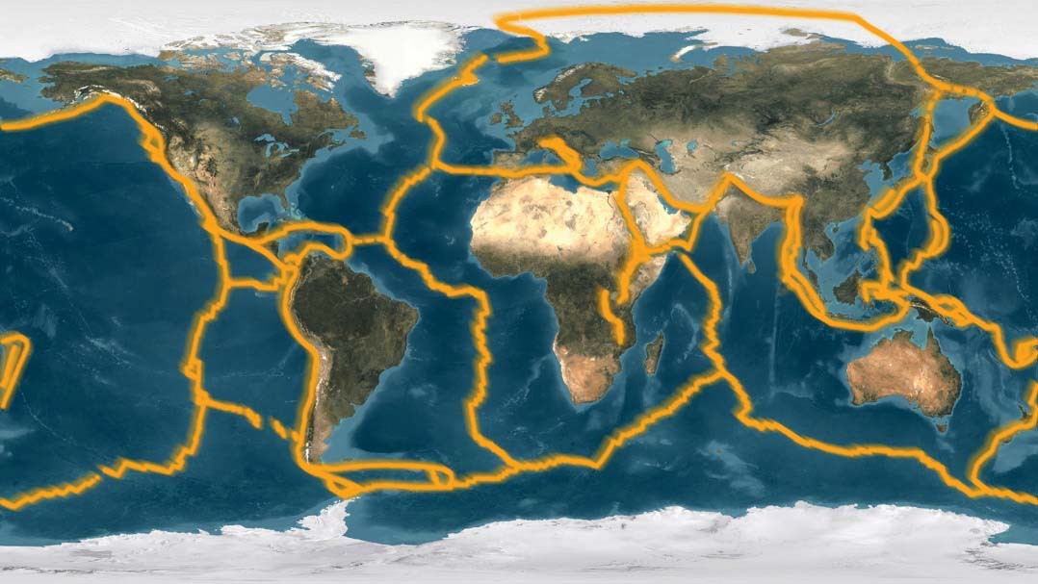
Earth’s surface is broken into massive rocky plates called tectonic plates.

- Over the years, seismologists devised various magnitude scales as measures of earthquake size. The “moment magnitude” scale is used today.

Most earthquakes occur along certain plate boundaries called subduction zones. A subduction zone is where a more dense oceanic plate subducts, or sinks below, a continental plate. Decades ago, scientists recognized that a subduction zone runs along the Pacific coast. It lies between southern British Columbia and northern California. It’s called the Cascadia subduction zone.

The two largest earthquakes since 1900 occurred along subduction zones. They were a Chilean earthquake of magnitude 9.5 in 1960, and an Alaskan earthquake of magnitude 9.2 in 1964. During each of these earthquakes, the continental plate lurched 20 meters toward the sea. This movement thinned the plate by stretching its rocks. The thinning lowered the coast enough for tides to drown coastal forests. Today, ghostly tree trunks provide natural clues that the huge earthquakes occurred.

Clues of Ancient Quakes

Earth scientists have found similar, much older remains of flooded forests in Cascadia. They were discovered along bays and river mouths on the coasts of British Columbia, Washington, Oregon, and northern California. Scientists also found other evidence of strong earthquakes in the same locations. These include sheets of sand that were deposited by floods from the sea and ground cracks that were filled with quicksand. Scientists concluded that earthquakes of magnitude 8 or larger have struck Cascadia repeatedly in the past several thousand years.

Teams of scientists worked together to determine the exact date and an approximate size for the most recent of these Cascadia earthquakes. First, American scientists discovered clues in some dead trees. The trees recorded sudden lowering of coastal land during this earthquake. Radiocarbon dating showed that they died between 1680 and 1720.

Japanese researchers were paying attention to these discoveries in North America. They knew that if the Cascadia earthquake was big enough, it would have started a tsunami in the Pacific Ocean. And they had been looking for the mysterious source of a tsunami that caused flooding and damage in Japan in January 1700.
They proposed that a great Cascadia earthquake occurred in the evening of January 26, 1700. They estimated its size as magnitude 9.

To test this proposed date and size, American scientists returned to some of the earthquake‐killed trees in Washington. By measuring thin and thick rings, they assigned dates to individual tree rings. They were able to narrow the time of the earthquake to the months between August 1699 and May 1700. This evidence supported the date proposed by Japanese researchers. The findings combined to give the 1700 Cascadia earthquake a place in history.

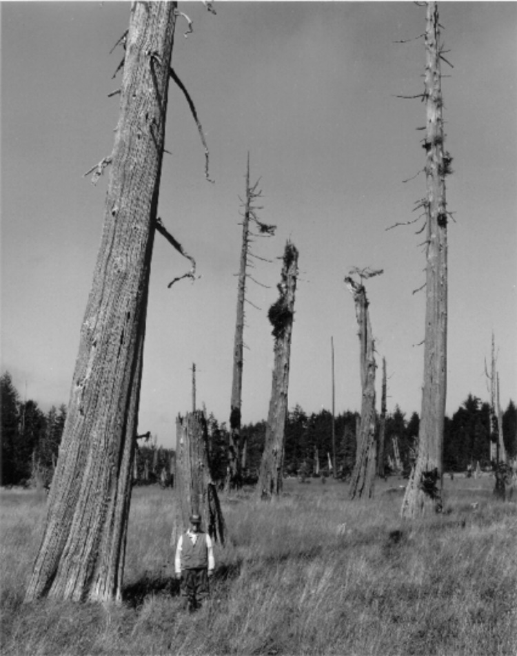
Scientists study dead trees in a tidal marsh along the Pacific coast of Washington. They provide evidence that a great earthquake occurred in January 1700.

Northwesterners Respond to the Risk

Earthquakes can’t be prevented. However, people can take measures to minimize the damage they cause. In some cases, communities can strengthen structures that already exist. These include dams, bridges, water systems, schools, hospitals, and lifelines (electrical, gas, and water lines). They can also design and build earthquake‐resistant structures in the future.

Until 1994, the Uniform Building Code2 placed an area of Washington in a zone with the second highest hazard level (out of six). Most of the rest of Oregon and Washington was placed in a zone with a lower hazard level.
The 1994 edition of the Uniform Building Code redrew the map for the Pacific Northwest. All parts of Oregon and Washington that are at risk of great earthquakes were upgraded to the higher‐level hazard zone.

This revision of the code was an important first step toward meeting the great‐earthquake threat in the Pacific Northwest. In the areas upgraded to the second highest level, new buildings are designed to withstand earthquakes fifty percent stronger than under the old code.

- The Uniform Building Code was replaced in 2000 by the International Building Code.

How Safe Are Other Parts of the United States?

People in other earthquake‐prone states started asking questions about whether they were adequately prepared for future earthquakes. These states include Massachusetts, New York, South Carolina, Missouri, Indiana, Utah, California and Alaska. Many of the questions cannot be answered satisfactorily until we know more about past earthquakes. Deciphering the geologic past is one of the ways that Earth scientists help to protect people from loss of life and property.

This reading was adapted from a 1995 USGS Fact Sheet, “Averting Surprises in the Pacific Northwest,” by Brian
F. Atwater, Thomas S. Yelin, Craig S. Weaver, James W. Hendley, II.

PUT YOUR MULTIPLE CHOICE ANSWERS HERE: Just the letter is sufficient:
1.
2.
3.
4.
5.
6.
7.
8.

Answer the essay questions here:

8.

9.

10

This article was originally scanned in, so it is difficult to put the answers here. Please use the text box on the previous page.

Genetic Basis of Butterflies

By ReadWorks
If you’ve ever been in a park during the summer, you may have seen butterflies flitting from flower to flower. They are quite beautiful, and like humans, seem to have individual traits. There are orange butterflies with big brown eyes, blue butterflies with black markings on their wings, and white butterflies with small black antennae. According to some butterfly experts, there are approximately 20,000 kinds of butterflies in the world. Each species (or type) of butterfly has its own genetic information that dictates what characteristics it will have and distinguishes it from other butterflies.
Inherited genetic information explains why certain species look different from others. Monarch butterflies, orange butterflies with black markings and white spots on their wings, are most common in Mexico and the United States. Their bright color makes them easily noticeable to predators, but also acts as a warning that they are poisonous if eaten.
How do we know that their bright and beautiful coloring reveals that they are poisonous? Well, what we think of as butterflies are the adult versions of caterpillars. As caterpillars, monarchs feed on milkweed, which contains a toxin that is poisonous to most vertebrates but not to monarch caterpillars. When the caterpillars become adult monarch butterflies, the milkweed in their bodies is poisonous to any predators that might try to eat them.
An unsuspecting predator that did not know the monarch butterfly was poisonous would soon realize its mistake. After tasting the poisonous bug, most predators quickly spit out the monarch and learn not to eat them again. Unlike other butterflies, whose genetic information (and therefore their coloration) helps them blend into their habitats in order to defend themselves from predators, monarch butterflies rely on their bright coloration to keep them safe. An interesting fact: another species of butterfly, the viceroy, mimics the coloration of the monarch in order to keep predators from eating it!

Even though there are many kinds of butterflies that look very different, all butterflies share a certain number of traits, which are also determined by their genetic information. They all have the same life cycle. First a caterpillar hatches from an egg. The caterpillar eats plants and grows bigger. Then it covers itself in a hard case called a chrysalis, and it enters a stage of transformation. During this stage, the insect is called a pupa. Inside the chrysalis, the pupa grows the legs, wings, and other parts of an adult butterfly. Once the butterfly is fully developed, the chrysalis splits apart, and the butterfly emerges. All butterflies have four wings—two upper, two lower—that are covered in tiny colored scales. A butterfly’s genes determine the color of its scales, and more—they dictate the insect’s size and shape as well.
Colorful decorations are key to the survival of the monarch butterfly. Vivid colors signal danger to the predators which might otherwise eat the butterfly. Other species of butterfly, with different genes, rely on different survival strategies, and have their own distinctive designs. But no matter the pattern, the blueprints for each of the 20,000 different species’ development are written in their genetic codes.

Name: Date:

- What does genetic information dictate, or control?

  - what characteristics an organism will have
  - where an organism will live and die
  - which predators will eat the organism
  - who the organism’s parents were

- The passage describes the sequence of a butterfly’s life. Which of the following shows the life cycle of a butterfly in the correct order?

A egg, pupa, adult, caterpillar B pupa, egg, caterpillar, adult C egg, caterpillar, pupa, adult D egg, pupa, caterpillar, adult

- Monarch butterflies are protected by their bright coloration. What evidence from the passage supports this conclusion?

- Their bright coloration makes monarch butterflies easily noticeable to predators.
- The monarch’s color warns predators that they are poisonous, so they don’t get eaten.
- Unlike other butterflies, monarchs do not blend into their surroundings to protect themselves.
- If a predator eats a monarch, it can taste the poison and will spit the butterfly out.

- Butterfly A is blue with black markings. Butterfly B is green with brown spots. What conclusion can you make about these two butterflies?

- Both butterflies protect themselves by blending into their surroundings.
- The two butterflies have different life cycles.
- Both butterflies have the same genetic information.
- The two butterflies have different genetic information.

- What is this passage mostly about?

A monarch butterflies B viceroy butterflies C milkweed toxins
D caterpillars and pupae

- Read the following sentences: “Inside the chrysalis, the pupa grows the legs, wings, and other parts of an adult butterfly. Once the butterfly is fully developed, the chrysalis splits apart, and the butterfly emerges.”

What does the word “developed” mean?

- young and small
- changed and grown C safe and protected D soft and vulnerable

- Choose the answer that best completes the sentence below.

Monarch butterflies are brightly colored; , they are highly visible to predators.

- however
- for example C as a result D initially

- Why are monarch butterflies poisonous?

- How do predators know that monarch butterflies are poisonous?

- How does the monarch’s coloration help both the butterfly and its predators?

Back Roads

By Vinnie Rotondaro
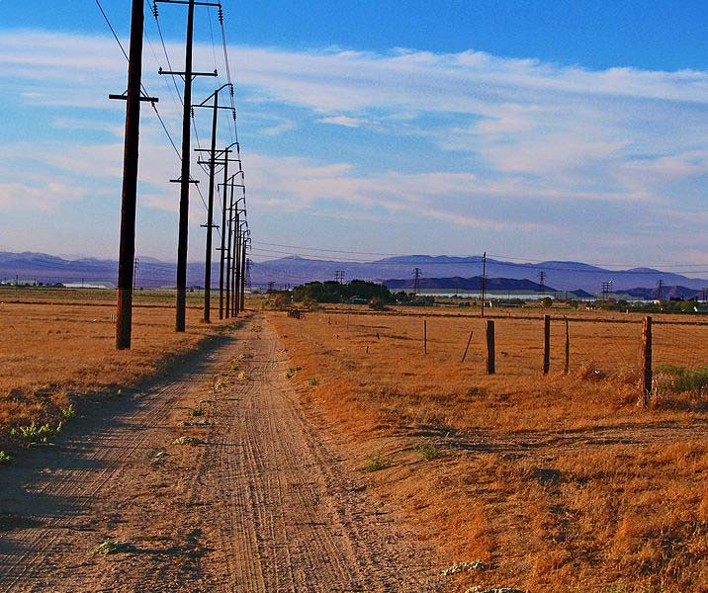
Joe pulled up in a red Jeep Cherokee, put the car in park and let the engine idle. It was about 10:45 in the morning, a Friday. Sam arrived a few minutes later fresh off of the subway, duffle bag slung over his back. The sun was clear white that day and shining down hard. It was almost spring. Joe honked the horn, and when Sam spotted the car, he pointed to the sky and started walking over.

Reaching into the backseat, Joe popped open the door opposite him so Sam could toss his stuff in, which he did, shutting the door and climbing into the front seat. Sam and Joe clasped palms in salutation. Sam was wearing jeans, a jean jacket and some boots. Joe was in grey sneakers and a blue hoodie. They were ready to roll.

The two were on their way to Pittsburgh from New York City. Sam hated rushing things and insisted that they take back roads. Joe was in. After inching their way through the Holland Tunnel and creeping along an expanse of industrial wasteland in New Jersey, they rolled onto a tree‐lined road running parallel to the highway, and cruised a cool 60 miles per hour with the windows down.

Eventually, they made their way into the country. Joe found the historical markers that dotted the sides of the roadway interesting—the ones next to old colonial stone houses and scenic graveyards, and the like—and every now and then—this was a decidedly relaxed ride—he would pull over to read them.

Somewhere in the middle of Pennsylvania, he spotted one that was about an old bridge. The bridge itself could barely be seen—a thicket of barren trees obscured it. But a shining band of bright white light could be seen. It was a river, and the sun was all over it.

Joe sidled the car up to the sign. He hugged the outside of his door and took off his black sunglasses. Squinting, he read:

ROCKVILLE BRIDGE

The longest stone masonry arch railroad bridge in the world, visible to the south, was built between 1900 and 1902. Named for the surrounding small settlement, it has forty‐eight arches and a length of 3,820 feet. It is the third bridge constructed here by the Pennsylvania Railroad. A wooden structure has been built 1847‐49, followed by an iron bridge in 1877.

The two pulled back onto the road and drove up a bit further where they found an opening in the trees. A clear site of the river spilled into view. It was the Susquehanna River that was branching out before them, beautiful and mighty. They looked at the bridge. It laid low along the water and was made out of weathered stone. One arch after another crossed the water. Above the bridge and the water alike, a sloping wooded mountaintop sat in the sky.

The men drove on. A few miles down the road they ran into a town called Dauphin Borough. The town was located along a bend in the Susquehanna, just off its banks.

Joe found a gas station and pulled in to fill up. They had a direct view of the river. Sunlight dappled the water, which rushed over rocks where shallow and flowed slowly where deep.

Sam opened his door and stumbled out onto the pavement. He stretched out in the beauty that lay before him. He walked down to the river. After filling up the tank, Joe pulled into a parking spot and called down to him.

“This place is incredible,” he hollered. Sam came jogging up.
“It’s so great down there,” he said grinning. “Hey, I’m going to go into this diner and use the bathroom.”

“Cool,” Joe said.

Sam ran across a lawn of freshly cut green grass, pulled open the door and walked inside.

Joe leaned against the jeep. Looking down at the water, he breathed in the deep cool air. About ten minutes later Sam came out of the door with a burger in his hand and a brown paper bag full of French fries.

They hopped into the car. Sam stuck his hand out the window and slapped the top of the jeep.
Pop Pop! They hit the road. As they were on their way out of town, Sam called out, “What’s that?” “What is what?” said Joseph.
“That thing out there,” Sam said. “It’s like a white statue, or something.”

Joseph craned his neck around and caught a glimpse of it. He shook his head in disbelief. Out there in the middle of the river on a hunk of grey stone, there it sat, glowing white in the sunlight.

“It looks like a miniature Statue of Liberty,” said Sam. “See how the left hand is holding up a torch.”

“Yeah I do,” said Joseph. “Look that thing up on your phone.”

Sam entered “Dauphin Borough Statue of Liberty” into an Internet search on his smartphone.

It was built by a local area resident, a lawyer, he learned, out of plywood and venetian blinds, and erected in secret late at night one night with the help of some friends. No one else in the town knew he was going to do this, so when everyone in Dauphin Borough woke up the next day and looked out over the river, it was as if the white statue had risen miraculously from the water.

Over the years it had been blown over by wind, reconstructed and raised again. These days it’s just considered part of the town.

“You know” Sam said, “America is amazing.” “Yes it is,” said Joe.
“That’s why these back roads are so great,” Sam said. “You get to see all these things.”

The two agreed it would be foolish to ever drive on a major highway. With the sun starting to set, they kept moving towards Pittsburgh where Dan was waiting. Dan was engaged to be married, and Sam and Joe were going to take him on a road trip to Texas before his wedding. This was how the trip began.

Name: Date:

- Joe and Sam are on their way to which location?

  - Dauphin Borough
  - the back roads of Pennsylvania
  - New York City
  - Pittsburgh

- The main setting of this story is

- Pittsburgh on a hot summer day
- Rockville Bridge on a lazy afternoon
- along back roads over the course of a day
- an airplane flight to Texas

- Read the sentences: “Sam hated rushing things and insisted that they take back roads. Joe was in.”

Based on this information, it can be concluded that

- Sam and Joe did not want to go to Pittsburgh.
- Sam and Joe are generally relaxed on road trips.
- Sam and Joe are generally very stressed on road trips.
- Sam and Joe have known each other for a very long time.

- How do people in Dauphin Borough most likely feel about the statue?

- They believe it is a sign from a higher power.
- They embrace its presence.
- They are confused by its miraculous appearance.
- They pay little attention to it.

- This story is mostly about

- the difference between natural and man-made landmarks
- the importance of taking time to appreciate nature
- a friendship formed through the bond of sharing a car ride together
- the beautiful and interesting things to be discovered along back roads

- The tone of the writing throughout the passage can be described as

- frantic, or hurried
- relaxed and smooth
- suspenseful and unusual
- exhilarating, or exciting

- Choose the answer that best completes the sentence below.

Joe and Sam decide not to take the highway they could drive through back roads.

- even though
- so
- instead
- next

- The presence and appreciation of nature is evident throughout the story. Identify at least three phrases or sentences that support this claim.

- What did Joe and Sam enjoy about their trip?

- Sam and Joe’s trip to Pittsburgh would have been quicker had they taken the highway. Why was it more worthwhile that they drove through the back roads?

Worldwide Loss of Bees a Growing Concern

Alissa Fleck
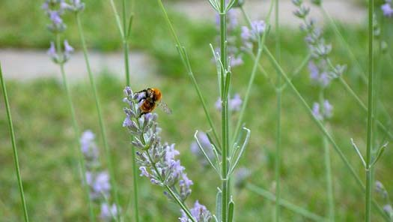
When we think of bees, we think of pesky, buzzing insects that sting us and ruin outdoor gatherings. We might wonder: how badly can we possibly need bees? The truth is, bees are an incredibly important part of our ecosystem on earth—no matter how annoying they may be to humans. Unfortunately, bees have been disappearing around the world for some time now, and their mass disappearance continues to present new problems around the planet.

According to Reuters news source, scientific researchers have been trying desperately for the past 15 years to understand why honeybees around the world are dying off at frighteningly high rates. Over 1 million bee colonies disappear every year, never to return, Reuters reporters noted in 2012.

Kevin Hackett, the national program leader for the bee and pollination program at the U.S. Department of Agriculture (USDA), called the massive honeybee disappearance “the biggest general threat to our food supply.”

How could something so small be so important to us humans? Bees are used to pollinate many crops, for instance a large portion of California’s almond crop, which relies heavily on bee pollination. Bees are also essential for the pollination of apple and citrus fruit crops. Without the pollination by bees, these plants are unable to reproduce and may die off.

The mass deaths of honeybees have been linked to something known as Colony Collapse Disorder (CCD)—a mysterious loss of bee colonies with many potential causes—as well as a variety of pesticides, parasites, and diseases, all of which hurt bee populations. Other possible causes include land development and changes in agricultural practices around the world.

There are numerous kinds and species of bees, and honeybees are not the only ones disappearing in large quantities. Bumblebees can be added to the list of pollinators whose

widespread disappearance worries scientists. While the dangers of losing bees, such as the damage to our food supplies, have long been known, researchers are uncovering even more distressing information about the loss of these ecologically crucial insects.

According to researchers who published their findings in the Proceedings of the National Academy of Sciences in 2013, the disappearance of bumblebees offers new cause for concern: certain plants are having difficulties reproducing with the loss of their bumblebee pollinators, and are at higher risk for extinction.

Two scientists, who conducted research on the impact of bumblebee loss on plant reproduction, found that when a particular species of bumblebee was removed from the pool of pollinators, other bees did not completely take over the pollinating duties. Instead, with less competition from the bees which had been removed from the pool, the remaining bumblebees flew between many different plants and were less likely to be faithful to one kind of plant.

The researchers noted this experiment had damaging effects. For instance, the larkspur, a purple wildflower, requires pollination from its own species—other larkspurs—to survive. The researchers found with fewer bumblebees, the remaining bees were “less faithful” to a particular plant, meaning the larkspur was unable to survive as it would have before the loss of bumblebees.

This particular study highlights the importance of bees to the continuation of, not just our food supply, but also all biodiversity, as the effects of this study do not end with the larkspur plant alone, but point to a much larger issue. The larkspur is just one example of this issue.

In 2012, the USDA and Environmental Protection Agency (EPA) released a joint statement discussing the issue of bee loss, and the search for a solution to the cycle of problems caused by bees dying off.

The organizations concluded: “No single silver bullet will solve the problems affecting honey bees and other pollinators.”

In terms of solutions, the organizations proposed: “Habitat enhancement...targeted pesticide use, improved colony management techniques and improved disease and pest resistant stocks of bees are collectively needed to improve the health of honey bee colonies.”

“It is imperative that we increase honey bee survival both to make beekeeping profitable,” the statement noted, “but more importantly to meet the demands of U.S. agriculture for pollination and thus ensure of [sic] food security.”

- What problem does this article mainly discuss?
  - Bees can sting us.
  - Bees can ruin outdoor gatherings.
  - Bees are disappearing around the world.
  - Bees are annoying to humans.

- Experts think that pesticides, parasitess and diseases, as well as land development and changes in agricultural practices around the world, are some possible causes of bee death.
According to this article, what is the most important effect of this new bee shortage?
  - Researchers are publishing new findings .
  - Many crops will be unable to survive without pollination.
  - Scientists are studying bees.
  - Gardeners are having a harder time growing larkspurs.

- In the article,Kevin Hackett, the national program leader for the bee and pollination program at the U.S. Department of Agriculture (USDA), calls the massive honeybee disappearance "the biggest general threat to our food supply."
What evidence from the article supports his claim?
  - Honeybees are not the only ones disappearing in large quantities.
  - Bees are used to pollinate many food plants,such as California's almond crops, apple crops and citrus fruit crops.
  - The larkspur,a purple wildflower, requires pollination from its own species-other larkspurs-to survive.
  - Over 1million bee colonies disappear every year, never to return.

- Leaders from the U.S. Department of Agriculture (USDA), researchers from the National Academy of Sciences, and the USDA and Environmental Protection Agency (EPA) are all reported to be working hard to understand and solve the problem of the disappearance of honeybees. Based on this evidence, what can be concluded about the organizations trying to solve this problem?
  - The organizations do not play an important role in keeping humans and the environment safe.
  - The organizations play an important role in keeping humans and the environment safe.
  - The organizations are dealing with a problem that is not relevant to their focus.
  - The organizations are being forced to deal with a problem they do not care about.

- What is this article mostly about?
  - threats to bees' health from human development
  - the origins of the crops we eat
  - the science of bee pollination
  - the causes and effects of bee death around the world

- Read the following paragraphs:
"In 2012, the USDA and Environmental Protection Agency (EPA) released a joint statement discussing the issue of bee loss, and the search for a solution to the cycle of problems caused by bees dying off.
"The organizations concluded: 'No single silver bullet will solve the problems affecting honey bees and other pollinators.'
"In terms of solutions, the organizations proposed : 'Habitat enhancement ...targeted pesticide use, improved colony management techniques and improved disease and pest resistant stocks of bees are collectively needed to improve the health of honey bee colonies."'
As used in the passage,what does the phrase "silver bullet" mean?
  - a complex solution
  - an easy solution
  - a pollinating bee
  - a dangerous pesticide

- Choose the answer that best completes the sentences below.
Bees are an incredibly important part of our ecosystem on Earth-no matter how annoying they may be to humans. _, bees have been disappearing around the world for some time now, and their mass disappearance continues to present new problems around the planet.
  - Instead
  - First
  - However
  - Finally

- What has the mass deaths of honeybees been linked to?

- List two reasons why the USDA and Environmental Protection Agency (EPA) believe that "it is imperative that we increase honey bee survival."

- Explain the impact honeybees and humans have on each other. Use evidence from the text to support your answer.

The Run
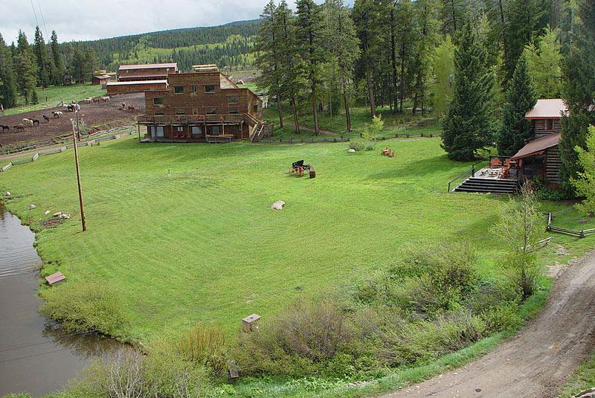
Dennis and Mac had been driving for almost a week, and they hadn’t seen a single soul.
They were worried. When they’d left the ranch, they’d thought maybe they’d run into someone, another survivor. But there was no one. The roads were almost empty. There was the occasional abandoned car, but that was it. They drove mostly on highways, to make better time. Mac wondered if they might not have better luck on the smaller country roads, but Dennis wouldn’t have it. Those roads had curves and were thick with trees. There was no way of seeing danger coming. If someone wanted to spring a surprise on you, you wouldn’t know it until it was too late.
When the plague came, Dennis and Mac had been working as ranch hands on a cattle farm. Both had just finished their first year of college. Dennis went to school on the East Coast, Mac on the West. They found that they were very similar people. They both studied hard and read a lot of books. But they also both liked being outdoors. At the end of a good day, they came home smelling of sweat and dirt. They quickly became friends.
The ranch was a small, family‐run operation, with only about 50 head of cattle. The family that ran it, the Greersons, would advertise in college newspapers in the spring. There were plenty of ranch hands in the area who needed work, but Bucky Greerson felt city kids

could benefit from an exposure to country life. Young men would apply, and then the Greersons would hire about a half‐dozen hands every spring to help them run cattle. It was tough work, but Dennis and Mac felt lucky to be picked.
The farm didn’t have a TV or the Internet or a telephone. As a result, the first they heard of the plague was on the radio. Every night, the ranch hands liked to gather in the mess hall and play cards. While they played, they listened to the radio. The ranch was so far up in the hills that the radio only got one station. At night they listened to the station’s best DJ, Petey “The Muskrat” Coltrain, who spun old bluegrass records. Sometimes, between records, The Muskrat told stories. Dennis and Mac thought he was hilarious.
One night, though, The Muskrat’s radio show was very different. It couldn’t have been more than six months ago, but to Dennis and Mac, thinking back on it now, it felt like another lifetime. The Muskrat had been playing a cheery Bill Monroe song, “Footprints In The Snow,” when he cut out the record halfway through the chorus. The ranch hands stopped their game of Gin Rummy. They turned and looked at the radio. The Muskrat always played a record all the way through. What could be wrong?
“Folks,” said the Muskrat. “I don’t know how to tell you this, but I’m going to ask you to stay very calm. The manager of my station has just passed me a note. It seems that the local health authorities are asking us radio folks to tell you, our listeners, that… well, a disease is spreading.”
The ranch hands put down their cards. Dennis and Mac exchanged a glance.
“Now,” The Muskrat said, his rich voice sounding uncharacteristically shaky, “they don’t quite know what this disease is, but it’s real bad. It’s very contagious, and people who get it don’t have a lot of luck recovering. Now, doctors are trying to figure out a cure, but there’s been no luck yet. So, in the meantime, we’re asking that you stay in your homes as much as possible and avoid public places until the disease dies down.”

One of the ranch hands, a big, cocky boy named T.J., laughed. “Like heck I’m not going into town,” T.J. chuckled. “I got a date.” The other ranch hands stared at him. T.J. stopped laughing.
“Please, folks, do what the doctors say,” The Muskrat pleaded. “I’m sure it’ll just be for a few days.” He was quiet for a moment. Then the ranch hands heard the sound of a turntable needle hitting the record, and an old Earl Scruggs song came on.
That was the beginning of it. For the next few days, the ranch went about its business. The Greersons told the boys not to worry, that this would all be over soon. They had enough food on the ranch to last months. In the meantime, there were plenty of new calves that needed branding. At night, everyone gathered around the radio and listened to updates. The news seemed only to get worse. More and more people were getting sick. The symptoms were strange. People would become violently ill, then fall into a long, deep sleep. The big cities — New York, Los Angeles, Chicago — had become like ghost towns. No one would go out into the street for fear of catching the disease.
The news kept getting worse until, finally, the radio station stopped transmitting. The Greersons called a meeting in the dining room of the main house. Everyone sat around the big dining room table where Ann Greerson served Sunday supper. After everyone was seated, Bucky Greerson stood up. He was a short, plump man with a droopy handlebar mustache. You wouldn’t think it looking at him, but his voice boomed.
“Now,” he said, “I know you’re worried about your families, and I don’t feel right chaining you here while you don’t know what’s become of your people. So, anyone who wants to leave is free to go. Ann and I will make do.”
Dennis and Mac looked at each other. They’d talked about leaving but had tried to pretend they wouldn’t need to. They had hoped the plague would be over soon, that the world would return to the way it was, that it had all been a strange hallucination. Now that

they had the option to venture out into the world, to see how bad things really were, they weren’t sure they wanted to know.
“By a show of hands,” Bucky Greerson asked, “how many of you want to leave?” Mac and Dennis looked around. They were the only two with their hands up.
The Greersons gave them enough food to last a couple weeks — corn bread and apples and cured ham and syrupy peaches in mason jars. Mac and Dennis packed up their things and loaded everything into Mac’s truck, a sputtering old pickup. The Greersons and the ranch hands gathered around to see them off.
“Be safe, boys,” said Ann Greerson, kissing them each on the cheeks and hugging them hard. “And remember your manners.” As Mac and Dennis pulled away, they saw her husband holding her, her body shaking with sobs.
A week later, Mac and Dennis had zigzagged through dozens of small towns and a few larger cities. What they found frightened them: every place was empty. Not a person was out. Sometimes, they would stop and knock on doors. No one would answer. If they went inside, they wouldn’t find a single soul home. Sometimes they’d find the dinner table set, plates piled high with molding food. Every time they entered a new room, they both winced, thinking they’d find a dead body. But they never did. It was indescribably eerie.
Sometimes, if the place still got electricity, they’d try to use the phone. Every time, no matter what number they dialed, the same recorded message came on: “The number is not in service. Please check the number and try again.”
Finally, the young men decided to make tracks to the nearest big city. It would be a full day of driving, but there had to be someone there. You can’t abandon a whole city.
Dusk had come, and Mac was at the wheel. Dennis had been driving for the last eight hours and was taking a nap in the passenger seat. They were passing through a long, flat piece of pastureland when Mac saw a flicker of movement in the distance. He stopped the car,

turned off the engine and shook Dennis awake.
“Look,” Mac said excitedly. “I think someone’s coming.”
Dennis squinted his eyes. The flicker of movement was becoming larger. What had been a dot of motion became a long line, stretching across the horizon. Mac and Dennis strained to see.
“I think it’s some people,” said Dennis. “Let me get my binoculars.”
He rustled in his backpack and pulled out his pair. Dennis put them to his eyes and looked through them. Mac heard him gasp.
“My gosh,” whispered Dennis.
What he saw was people. Thousands of people. Hundreds of thousands, maybe a million. A swarm of people like the world had never seen. And the people were all running. They were running as fast as they could go, like something was chasing them, or like they were chasing something. As they grew closer, Dennis could just make out the people’s faces. Their eyes were wild.
“Start the car,” said Dennis.

Name: Date:

- What news do Dennis and Mac hear on the radio while at the ranch?

A There is a cattle farm that hires young men to work over the summer. B Thousands of people are running as fast as they can across the country. C There is a bad disease spreading among people.
D Food is getting moldy on dinner plates because people are not staying at home.

- What is the sequence of events at the beginning of this story?

  - The story begins after the disease has struck and then takes the reader back in time to a point before the disease.
  - The story begins before the disease has struck and then takes the reader forward in time to a point after the disease has ended.
  - The story begins as the disease is striking and then takes the reader back in time to a point before the disease.
  - The story begins as the disease is striking and then takes the reader two years into the future.

- The Muskrat says that the disease is “real bad.” What evidence in the story supports his statement?
- T.J. wants to go into town even though The Muskrat has advised people to stay in their homes.
- After The Muskrat warns people about the disease, an old Earl Scruggs song comes on the radio.
- The Greersons tell the boys not to worry, saying that the disease will end soon.
- The disease is very contagious, and doctors have not been able to figure out a cure.

- Why do Dennis and Mac decide to drive to the nearest big city?

- They want to find a person.
- They are running out of food and need more.
- They see thousands of people running.
- They both like being outdoors.

- What is this story mainly about?

- a married couple who own a ranch, the young men they hire to work for them one summer, and the music they listen to together
- two young men, a mysterious disease, and what happens when they go out to explore after the disease hits
- a radio DJ, the music he likes to play, and the effect that his song choices have on the people who listen to them
- a long line of people running through a flat piece of pastureland and what happens when two young men see them

- Read the following sentence: “More and more people were getting sick. The symptoms
were strange. People would become violently ill, then fall into a long, deep sleep.” What does the word “symptoms” mean?
A fears of getting sick B signs of a disease C serious injuries
D suggestions that doctors give to patients

- Choose the answer that best completes the sentence below.

Dennis and Mac are frightened after leaving the ranch the towns and cities they visit have no people in them.

A although B as a result C because D however

- What happens to people when they get sick with the disease described in the story?

- What are the people Dennis and Mac see at the end of the story doing?

- Is there a connection between the disease and the people Dennis and Mac see at the end of the story? Explain why or why not, using evidence from the story.

NJ Physics Professor Has the “Right Stuff”

Valorie Sands
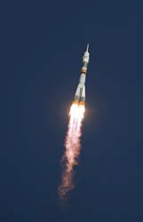
In 2005, Dr. Greg Olsen became the third person ever to travel into outer space as a private citizen. Unlike NASA astronauts who earn a generous salary, he bought his own ticket into space. He paid about $20 million for the trip, a ten‐day orbit aboard the Expedition 11 Russian Soyuz rocket, which docked at the International Space Station. He also took responsibility for his own training. The space flight was the achievement of a lifetime for the New Jersey entrepreneur and college physics professor.
Olsen's fascination with outer space and astronomy began when he was still a boy. He was born in 1945, years before space travel was close to becoming a reality. In fact, space exploration did not really heat up until the post‐WWII rivalry known as the Cold War between Russia and the U.S. Both countries fought to win the race to space.

The Race to Space
In 1957, the Soviet Union took the lead when it sent Sputnik, the world's first artificial satellite, into space. But by 1962, U.S. President John F. Kennedy made it clear that the nation would not take a backseat to Russia. “We choose to go to the moon in this decade... because that challenge is one that we are willing to accept, one we are unwilling to postpone, and one which we intend to win,” said Kennedy.
When asked why he loved space travel, Dr. Olsen talked about his professional crewmates, NASA astronaut Bill McArthur and Russian cosmonaut Valery Tokarev. “For the same reason they love it ‐‐ to be weightless, to see the awesome sight of Earth from space,” he said.

Spaceflight Training School
Going to space school for the Expedition 11 spaceflight “was also like being a college student again,” said Dr. Olsen. That is, except for some of the training, which involved zero gravity flights and spins around in a centrifuge of up to 8 Gs acceleration (eight times Earth’s gravitational pull). However, most of Dr. Olsen's training was spent in classrooms and in flight
1

simulators. He was expected to know his way around the Soyuz vehicle, the space station, and to help with day‐to‐day routines. Yet neither NASA nor the Russians assigned him to heavy‐ duty responsibilities during the space flight.
According to Olsen, the most physically challenging part of the training was the water‐ landing exercise to practice “splash down.” This is a demanding and dangerous method of landing a spacecraft by parachute into a body of water. To prepare for the grueling task, Olsen and his crewmates wore wet suits and other protective survival gear. During just two hours of practice, he sweated off more than three pounds from his 170‐pound frame.

Learning Russian
Despite demanding tests of endurance, Olsen described the physical training as the easiest part of preparation for the experience. He said that for him the hardest part “was trying to learn Russian. I love Russians and the Russian culture… but I’ve never been good at languages since I was a young person.”
Dr. Olsen learned Russian well enough to succeed in bonding well with his Russian crewmate and training personnel. “I’m just in awe of them,” he said. “When I watched them operate the Soyuz spacecraft and the simulators, they seemed to know every nut and bolt on the vehicle. I just tried to soak up the knowledge.”
Overcoming fear was no problem for Dr. Olsen. He was “very, very confident” about space travel aboard the Russian Soyuz vehicle. “It has a great safety record, and I have no qualms about doing this whatsoever.” The main goal of the Soyuz mission was to switch crews, and to replace emergency capsules that must always be attached to the space station in case of an emergency escape.

A Smooth Launch
Olsen’s launch from the Cosmodrome, a space launch facility in Kazakhstan, went smoothly. He reported that one of the most unforgettable highlights of his ten‐day trip was the lift‐off experience during takeoff. He was also awed by the sight of Earth passing by in the rocket's window and the memorable feeling of floating around the space station.

Radio Broadcast from Space
A licensed ham radio operator, Dr. Olsen spoke to New Jersey students from space via a ham radio. In the first of three broadcasts from the International Space Station (ISS) Olsen said, “Welcome to space. It's really nice here. It's nice and roomy."
"In some ways it's like camping out, because we have no running water, no sinks, and we kind of have to fend for ourselves for food," said Dr. Olsen. He reported that the professional astronauts had made him feel welcome aboard the space station.
2

Olsen expressed appreciation to many of his teachers, colleagues, and family in his space broadcast. He thanked his professors at Fairleigh Dickenson University in Teaneck, New Jersey, where he earned a Master’s Degree in Physics. He also thanked engineering students and former classmates at the University of Virginia, the school where he earned his doctorate. It was with their support that he was able to first build a spectrometer that became the basis for his New Jersey company, Sensors Unlimited. Spectrometers are sophisticated space age tools that use light to help astronomers and astronauts collect information. Using a spectrometer, astronauts can calculate the temperature of an object in space, learn which direction it’s moving, calculate its speed and weight, and find out what it is made of.

Scientific Studies from Space
Olsen had planned to take an infrared spectrometer built by his Princeton, New Jersey firm with him on his space trip. However, it failed to pass through U.S. Export Customs, so the project had to be shelved. Instead, he conducted three medical experiments designed to study the human body's reaction to the absence of gravity. He also conducted studies on bacteria growth in zero gravity, and on how spaceflight affects the lower back and inner ear. He contributed his scientific findings to the European Space Agency.

The Journey Home
During Olsen's return trip to Earth, there were pressurization problems aboard the Soyuz TMA‐6 spacecraft carrying him and his crew home. Overcoming the difficulties at undocking and during the descent tested the astronauts' skill, emotional strength and mental capability. In fact, at a press conference, a Russian News Agency announced that it had been a fairly serious situation. Fortunately, disaster was avoided because the Expedition 11’s astronauts all kept their cool and monitored the glitch very closely during re‐entry. All three space travelers wore Russian‐built Sokol spacesuits, a standard precaution, for an extra layer of protection, according to Olsen.
“At no time was there panic or alarm, or anything of that sort,” said Olsen about the pressurization problems during re‐entry. He added that at one point during the descent, he needed to add more oxygen into the Soyuz cabin. “We had practiced this many times during simulation practice, and I thought everyone handled it like pros.” Ten days after liftoff, the Soyuz crew landed safely back on Earth, in a desert in Kazakhstan.

3

Name: Date:

- Who is Greg Olsen?

  - a man who used to be the president of the United States
  - a student at Fairleigh Dickenson University in New Jersey
  - a NASA astronaut aboard the Expedition 11 Russian Soyuz rocket
  - a physics professor who traveled to outer space in 2005

- What does this passage describe?

- This passage describes the classes that Olsen took to earn his Master’s Degree in Physics.
- This passage describes the results of Olsen’s studies on bacteria growth in zero gravity.
- This passage describes the trip that a private citizen took into space and his preparation for it.
- This passage describes what the desert in Kazakhstan looked like when the Soyuz crew landed.

- Training for spaceflight takes a lot of physical effort.

What evidence from the passage supports this statement?

- Olsen tried to learn Russian even though he has never been good at languages since he was a young person.
- During just two hours of practice, Olsen sweated off more than three pounds from his 170 pound frame.
- While NASA astronauts earn a generous salary, Olsen had to pay $20 million for his trip into space.
- After World War Two, the U.S. and the Soviet Union fought to win the race to space during the Cold War.

- How did Olsen feel when he was up in space?

- nervous and scared
- foolish and embarrassed
- sad and disappointed
- happy and thankful

- What is this passage mostly about?

- Greg Olsen’s preparation for a flight into space and his experience in space
- the pressurization problems aboard the Soyuz TMA-6 spacecraft
- the infrared spectrometer that Greg Olsen planned to take on his space trip
- three ham radio broadcasts from the International Space Station

- Read the following sentences: “In 2005, Dr. Greg Olsen became the third person ever to travel into outer space as a private citizen. Unlike NASA astronauts who earn a generous salary, he bought his own ticket into space.”

What does the word “astronauts” mean?

- people who teach physics
- people who travel into space
- people who like to wear wet suits
- people who build spectrometers

- Choose the answer that best completes the sentence below.

Greg Olsen enjoyed his trip into space preparing for it was not easy.

A second B currently C although
D specifically

- What language did Olsen learn during his training?

- For Olsen, what result did learning Russian have?

- Explain how Olsen’s training prepared him for his trip into space. Give one example of something he learned during training that he used while in space.

Running a Real “Zombie 5K”

By Kyria Abrahams
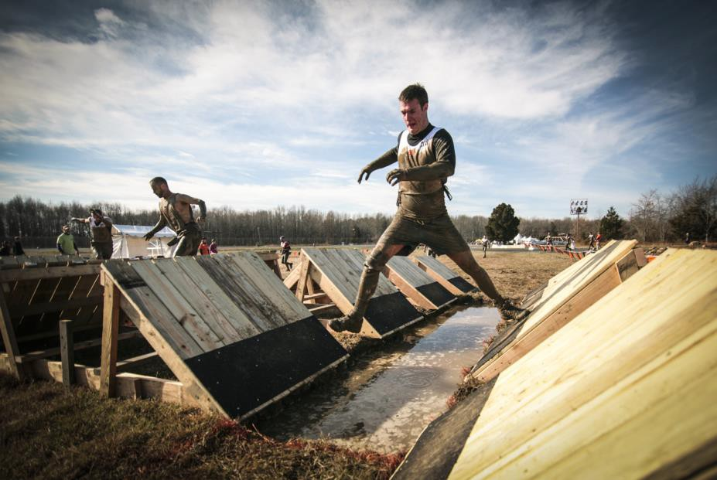

mom.
I exercise a lot and try to keep healthy. Last year, I ran in the Boston Marathon with my

Recently, I learned about something called Obstacle Course Racing. This is like a

marathon, but they have all these different types of obstacles for you to overcome. You have to climb over walls and slide down ropes. You even crawl through the mud.
They also have a “fun run” called the Zombie 5K. It’s a three-mile race during which you are chased by people dressed like zombies!
When I found out about the Zombie 5K, I knew I had to train for this race and win it. I went to the park and found an area where the city has built some free exercise equipment. They have a little jungle gym and some benches to do push-ups on.
Every day after school, I’d go home and change into my gym clothes. I’d ride my bike over to the park and lock it up real tight with a chain. Then, I’d spend about an hour doing pull- ups on the monkey bars and jumping over blocks of wood.
As I did this, I pretended that zombies were chasing me. Sometimes I would scream and run wildly around in a circle. This generally resulted in people looking at me sideways. People would start laughing and pointing. I didn’t care. I had a race to prepare for.
The only problem was, I didn’t actually know what it would feel like to run while being chased by zombies. So I called my friends Jeff, Amy, and Kristen. I asked if they wanted to have some fun helping me train.
Since it was close to Halloween, a lot of them had monster makeup lying around their homes. A zombie costume isn’t that hard—it’s mostly just old clothes that you were going to throw out anyway!

The next day, we waited until dusk. I went to the park as planned. I don’t know how Jeff and the gang got there. Maybe they changed into their zombie costumes behind a tree. Maybe they got dressed at home and then rode their bikes there (now that would have been funny!).
All I know is that I was running along the track when all of a sudden I heard a loud roar coming from behind me. I turned around, and there was Zombie Amy running full speed in my direction.
“BRAAAAINS!” she said.
“Aw, Amy, come on! That’s so cliché! No real zombie says ‘brains’!” I said.
She wasn’t stopping, though. In fact, she was getting faster. And she seemed to be foaming at the mouth. I noticed other families start to scream and scatter. I guess they believed she was really a zombie.
Amy was obviously really getting into the part, so I decided to play along. I ran as fast as I could until I got to the gate. I jumped over the gate and got the side of my shorts stuck on a prong. Amy wasn’t slowing down.
“Come on, Amy, it’s just a game!” I yelled. I struggled to free myself from the gate as she got closer and closer. Her eyes looked black, and I could smell her breath.
Suddenly, I felt an arm grab me around my waist and pull me off the gate. “Come on, let’s get out of here!” It was Jeff. He wasn’t in a zombie costume. “Jeff, why aren’t you in costume?”
“Because that isn’t a costume! She was bitten by a real zombie! Run!”
We started running. I could hear her close behind me now. I could still almost smell her.
We built up speed, and I ran faster than I ever thought I was capable of. Amy was doubling back around now, having gotten in front of us somehow. That’s when I saw Jeff grab his neck and start convulsing.
“Amy… she bit me a little bit,” he said. “Just a little.”
His eyes were getting dark, and he started foaming at the mouth. I knew I had to get to a place they couldn’t follow me: the outdoor gym.
I’d been training there for months. I knew the course backwards and forwards. I leaped over the sit-up planks and the balance beams. The zombies were falling all over themselves. They tripped on the grass and couldn’t stand up straight on the beam.
Since it had rained last night, there was a puddle of mud surrounding the monkey bars. I looked behind me to see my former friends were slowly gaining on me. I figured they’d fall in the mud puddle, but so would I! So I got my footing on a balance beam and jumped high into the air. I grabbed onto the first monkey bar and swung as hard as I could. The next thing I knew, I was all the way across on the other side.
My zombified friends were slipping around in the mud. They couldn’t even stand up straight. Panic was setting in. I knew I could keep running, but where was I running to? Where would I hide?

That’s when I saw Kristen.
She didn’t appear to be a zombie… yet. She was waving her arms frantically. Could I trust her? I decided that I had to. I had no choice.
I noticed Kristen appeared to be sobbing on the ground. But wait—no. She was laughing.
Our friends are monsters trying to murder us and she was laughing?
She pointed back towards Jeff and Amy, and they were on the ground laughing, too. “We got you… so… good!” Amy said, laughing so hard she could barely finish speaking. “You did what? Are you kidding me?”
“It’s a joke!” she said.
I was so incredibly angry. I mean, I was really livid! My face felt hot and flushed. “What’s wrong with you?” I asked them.
Amy came toward me, wiping away the fake foam from her mouth. Jeff was removing contact lenses.
“You smell horrible!” I said.
“Yeah, uh. We kind of rubbed some spoiled milk on our clothes before we came. You know, to get the full effect,” Amy said.
“You’ve got to admit it was pretty brilliant,” Jeff said. “You really tricked me, you guys.”
“We’re sorry,” Kristen said. “But I watched the whole thing. You owned that obstacle course, and you did it under pressure!”
“Well, I guess that’s true. I’m not nervous about the race any more!”
“You’re going to be amazing, and we’ll be there to cheer you on! In zombie makeup, of course.”
I started to laugh a little bit. I was still fuming mad and didn’t want to laugh. I just couldn’t help it.
“I knew real zombies didn’t say BRAINS!” I said. “You guys are hacks!” “BRAAAAINS!” said Amy, holding out her arms to my neck.
I couldn’t hold in the laughter any more.

- What does the main character decide to train for?
  - an obstacle course
  - the Boston Marathon
  - a Zombie SK
  - a pull-up contest

- What is the climax of this story?
  - when the main character finds out about the Zombie SK
  - when the main character asks her friends to help her train for her SK
  - when the main character is being chased by what she thinks are real zombies
  - when the main character realizes her friends are just pretending to be zombies

- The main character is in good physical shape. What piece of evidence from the text best supports this conclusion?
  - She ran in the Boston Marathon with her mother last year.
  - She knew she had to train for the Zombie SK and win it.
  - Every day after school,she would change into her gym clothes.
  - She would sometimes scream and run wildly around in a circle.

- What three words best describe the main character in this passage?
  - lazy,unhealthy,serious
  - hardworking,strong,gullible
  - cheerful,intelligent,weak
  - shy,quiet,lonely

- What is the main idea of this passage?
  - A girl trains for the Boston Marathon with the help of some terrifying zombies.
  - A girl trains for a Zombie SK with the help of her enthusiastic friends.
  - A girl gets chased through a park by a group of actual zombies.
  - A girl trains for a Zombie SK by doing pull-ups on monkey bars.

- Read these sentences from the passage: "Amy wasn't slowing down.
'Come on,Amy, it's just a game!' Iyelled. Istruggled to free myself from the gate as she got closer and closer. Her eyes looked black, and Icould smell her breath."
What feeling is the author trying to create with this description?
  - happiness
  - annoyance
  - disgust
  - suspense

- Choose the answer that best completes the sentence below.
The main character wanted to train for a Zombie SK, she asked her friends to act like zombies and chase her.
  - after
B) if
- but
- so

- Why did the main character ask her friends to help her train for the "Zombie SK"? Use evidence from the text to support your answer .

- The main character experienced different feelings at different points while she was running away from her "zombified" friends in the park. What are three different feelings she experienced while she was running away from her "zombified" friends? Use evidence from the text to support your answer.

- Explain whether her friends' zombie trick helped the main character feel mentally prepared for the "Zombie SK." Use evidence from the text to support your answer.

The Unknown Hall of Famer

Michael Stahl
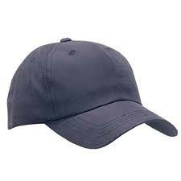
New York City is famous for many things: pizza, Broadway shows, skyscrapers, and baseball. The New York Yankees are possibly the best‐known sports team in the world. Baseball has been so popular in New York City that there have been four professional major league baseball teams, including the Yankees, that have made their homes in New York City since the beginning of the 20th century.

So many kids in New York have always wanted to play baseball. However, playing baseball can be difficult in such an urban setting if the game is going to look like the real thing. There needs to be a large grass field with a dirt diamond. The players need bases, bats, balls, and gloves to play with. In order to get a game of baseball going without having all of the required items, many New York City boys created their own version of baseball, one that would be played on the hard concrete streets. They would call it “stickball” because it could be played with a simple broomstick handle instead of a large, heavy bat. They’d use small, pink rubber balls instead of expensive hardballs made of leather and twine. Those kids, who were good, would incredibly one day find themselves in an actual Hall of Fame. George “Lolin” Osorio is one of those players.

Osorio’s family moved to Manhattan from his home in Puerto Rico when the ink on World War II peace treaties was still wet. In Puerto Rico, he was given his nickname because, as a very young boy, he was known to chase after a girl named Lola, so neighbors took to calling him the masculine form “Lolin” since the two always seemed to be together. At nine years old in New York City, he did not hesitate to immerse himself in the king of the street games—as long as his homework and chores were done. He and the other kids on his block would take to the streets in t‐shirts and cut‐off shorts to enjoy the “cheap game.” All they needed was one broomstick, a few rubber balls, and nine or so other guys from another block to prove themselves against.

“We’d play for a little money, five cents a game or a quarter when I was about ten years old,” Osorio says, recalling that if his team won, they’d often use their money to see a movie. Sometimes kids would save their winnings to buy two‐dollar Puma sneakers, which were more desired than one‐dollar Converses because they were better for running; plus, everyone knew they were twice as expensive.

“But really we played for bragging rights,” Osorio insists. “You were on the team from your block. You played for pride.”

“Lolin was one of the best because he always hit the ball hard on the ground, and was so fast that nobody could throw him out,” remembers Carlos Diaz, the curator of New York City’s Stickball Hall of Fame, of which Osorio is an esteemed member. “He was also very clutch and reliable. He could get a hit just about any time,” Diaz adds.

Osorio and his friends, who were all of Puerto Rican descent, would play stickball for hours; that is, until the Irish cops would show up. Though there were few cars driving through the city streets in those days and the rubber balls with which they played were as harmful to windows as a summer wind, many of the police officers would discover games and immediately order the kids to hand over their makeshift bats.

“I could never understand why they’d break up our stickball games,” Osorio says. “We played to stay out of trouble.”

For a time, Osorio remembers the cops slipping the sticks down into the sewer. But after the officer had moved along and the boys had faked disappointment long enough, one of the smaller kids would climb beneath street level into the muck and come up with the bat, covered in sludge. There was always an open fire hydrant somewhere they’d use to clean off the grime from both the bat and the brave boy.

“Then the cops got smart,” Osorio says. “They started taking our bats, hold them halfway down in the sewer’s grating and snap them in two.”

Still unafraid, Osorio and his block mates continued to play throughout their adolescence, traveling farther away from their neighborhood with each passing year, challenging players in various neighborhoods and having tons of fun.

A frequent teammate of Osorio’s, Alfred Jackson, another Stickball Hall of Fame member, remembers one particularly incredible shot struck by a rival of theirs named Tony Taylor. “He crushed the ball,” Jackson begins. “He hit it so hard that it went off the third‐floor siding of a building, came down, bounced off a car, hit the building again. Then it hit a lamppost and ricocheted to one of our outfielders who caught it for an out. The ball was in fair territory the whole time!”

As Osorio’s clan got older, more and more money was bet on their games. They can recall games played for upwards of three to five thousand dollars, with the victorious team getting a cut. Some players depended on winnings as a sort of additional income, so some teams felt pressured to win for their players’ financial stability. Fans who had their own best interests in mind heckled batters trying hard to focus on a potentially game‐changing pitch.

Still, money was not as important as the feelings of self‐respect and community, which truly compelled Osorio to go outside and play each and every Sunday, even 24 hours after his wedding. “I got married on a Saturday,” Osorio says. “We had a bunch of leftovers from the wedding in the refrigerator. The players’ wives always made food for all of us, so I woke up and packed the leftovers to bring to the game,” he laughs, adding with a shake of his finger, “My wife wasn’t very happy about that.”

In the late 1950s and throughout the ‘60s, Osorio made a living building clock radios—and, briefly, delivering zippers—but always found time to participate in the first organized stickball leagues that were emerging throughout Manhattan and beyond. Though he has continued to play, Osorio and his friends have seen the game nearly completely disappear.

“Not as many guys play anymore,” says Carlos Diaz, who has tried for many years to revitalize stickball in New York City. “And most of the young ones that do play are sons and grandsons of the guys who played fifty or sixty years ago.” Diaz’s efforts include opening a gallery this past winter, giving the Stickball Hall of Fame a more permanent home.

No matter what, Osorio still finds himself out on the streets of New York City every Sunday playing the game he loves, around the guys that he loves, all of whom have respected, and even honored him, for decades.

- What is stickball?
  - another name for baseball
  - a traditional Puerto Rican game
  - a version of baseball played in New York City
  - a street game played with a hockey stick

- What does the author describe in the passage?
  - Osorio's troubled childhood in Puerto Rico
  - the rules of stickball
  - how Osorio got rich by playing stickball
  - the origins and development of stickball

- Stickball is a "cheap" game. What evidence from the text supports this statement?
  - It can be played with minimal equipment.
  - It can be played on concrete streets.
  - It can be played for money.
  - It was only played by poorer children.

- What can be inferred from the following sentence:"Still,money was not as important as the feelings of self-respect and community,which truly compelled Osorio to go outside and play each and every Sunday, even 24 hours after his wedding."
  - Money is the main reason Osor io plays stickball.
  - Osorio really loves playing stickball.
  - Osorio is not very fond of his wife.
  - Osorio is not very religious.

- What is this passage mainly about?
  - the street game stickball and one of its best players
  - the way New York City kids can adapt to difficult situations
  - reasons why baseball is so popular in New York City
  - how the Stickball Hall of Fame was built

- Read the following sentence: "Osorio's family moved to Manhattan from his home in Puerto Rico when the ink on World War II peace treaties was still wet."
Why does the author note that the "ink on World War II peace treaties was still wet" when Osorio's family moved to Manhattan?
  - to show that Osorio's family moved a long time after World War II ended
  - to show that Osorio's family moved right before World War II ended
  - to show that Osorio's family moved right after World War II ended
  - to show that Osorio's family moved a long time before World War II ended

- Choose the answer that best completes the sentence below.
Police officers would break up games of stickball Osorio and his friends were not causing any trouble.
  - therefore
  - even though
  - primarily
  - specifically

- Why did children in New York City create their own version of baseball?

- Why did Osorio play stickball as a child, and why does he continue to play as an adult?

- How did stickball provide its players with a sense of community? Use information from the text to support your answer.

Across The Lake

W.M. Akers
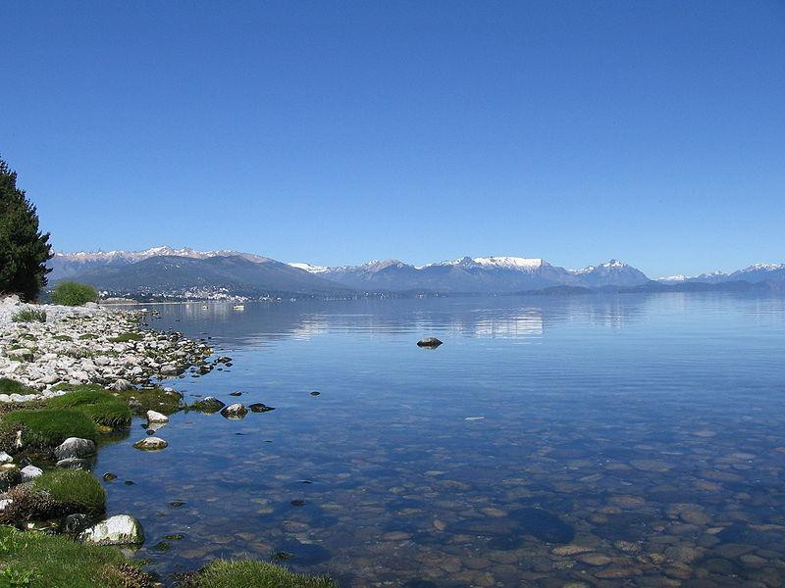

“What’s do you think’s over there?” asked Bart. “What do you mean?” said Patsy.
“On the other side of the lake. What do you think is over there?”

Patsy and Bart were sister and brother—twelve and eight years old. They were on vacation, but Patsy was bored out of her mind. Ever since Bart was born, their family had been coming to Lake Wenatchee, a crystal blue sheet which stretched as far as the eye could see. Ever since Bart was born, they had stayed in the same cabin, a musty old wreck just steps from where the water met the gritty beach. And ever since Patsy was 10, she had hated coming here.
The mosquitoes got bigger every year. By now they were larger, it seemed, than her fist. The humidity got worse, and the rain became more constant. If this is what people

meant by climate change, she thought, she was opposed to it. She spent most of the day reading in bed, stretched out on the scratchy blanket on the rock-hard mattress, wishing she was at home with her friends doing normal summer stuff: going to the mall, watching movies, eating popsicles in the park. She wished she was anywhere but Lake Wenatchee.
But there was nowhere else Bart wanted to be. He didn’t mind the humidity, he found the constant rain soothing, and thought the giant mosquitoes were the most amazing animals he had ever seen. He didn’t have time for reading on a scratchy blanket because he was in love with the lake. As soon as dawn broke, he was on its shore— building gritty sand castles from the gritty sand. He imitated the birds, trying to get their attention. He crept up on geckos, hoping they would want to play. He threw rocks in the water doing everything he could to entertain the fish. Bart loved nature—even if the towering mosquito bites that dotted his arms and legs were proof that nature didn’t love him back.
“I bet the other side of the lake is even better than this side,” he said. Trying to act interested, Patsy said, “What makes you say that?”
“It’s tough to believe, I know, because this side is so unbelievably super perfect.
There are birds and lizards and mosquitoes and fish. But something in my gut tells me that it’s even better over there.”

The summer before, Patsy and her mother had driven to the other side of the lake to buy shampoo at the drugstore. The other side of the lake was nothing too exciting: strip malls and gas stations, with a shopping mall in the middle. But before she told Bart the truth, she wanted to know what he was imagining. It would be more fun to burst his bubble that way.
“Describe it to me,” she said. “Tell me everything that’s on the other side of the lake.”
“Fish, obviously. But much bigger ones, I bet. The kind we saw at the natural history museum last year—like the super-underwater kind that have the little lamp hanging in front of their eyes. I bet there’s a whole bunch of those. And birds, too—obviously—but great big huge ones. Not just seagulls and stuff—falcons, hawks, and snowy owls.”
“And bald eagles, too, I bet.” “Tons of them.”
“Do you know what they call a group of eagles?” “I don’t know…a flock?”
“A convocation.” “No way.”
“It’s true! I learned it in science class last year.”

“So if I went to the other side of the lake, I’d see a convocation of eagles?”

“Uh…I don’t know.” Bart tossed a rock into the lake and watched the ripples drift slowly to the dock. He was appearing to lose interest.
“Come on, Bart! Let your imagination run wild. Anything in the world could be over there. So what do you want to see?”
“Well, uh…an ice cream store.”

“What kind of ice cream store? The best one in the world?” “Definitely.”
“What makes it the best one in the world?”

“Well, uh—all the ice cream costs 25 cents. And if you ask for a free sample, they give you a whole scoop. And they have all kinds of crazy flavors, like butternut peanut butter walnut, and triple chocolate marshmallow fluff surprise.”
“Triple chocolate marshmallow fluff surprise? What’s the surprise?” “More marshmallow.”
Patsy felt her stomach give a rumble. “Huh. That actually sounds really good.” “Of course. And next to the ice cream store is a roller coaster park.”
“And all the roller coasters are free?”

“Yep. And each one has a double loop-the-loop.”

“You’d better ride that before you go to the ice cream store, not after.”

strangely impatient. She wanted to know what else was on the other side of the lake. “Is there anything that I will like?”
“You like ice cream.” “Yeah, but what else?”
“Uh, I don’t know. I guess there’s probably a movie theater and stuff.” “But I can see movies at home. What’s over there that’s special?”
“There’s a clothing store where they give you five free outfits, just for coming in the door. And all the clothes fit you perfectly, and the sales ladies are never mean to us, just because we’re kids.”
“Oh man, that sounds great.”

“Yeah! And…” Bart tried to remember what else his sister liked. “There’s a place where you can get free notebooks for school!”
“Really?”

“The really expensive kind, with the heavy paper and colorful covers and stuff. And you can have all the fancy pens you want!”
“That does sound nice…”
“Wait a minute! Didn’t you and Mom go over there last year? To buy shampoo or something?”

“Well, what was it like?”

Patsy remembered the strip malls and gas stations—a lake of concrete, where the humidity was unbearable and the mosquitoes, somehow, even bigger—and she looked at her brother’s hopeful, dreaming face.
“It was exactly like what you said,” she said. “Free ice cream and roller coasters and everything. Exactly like that.”

Name: Date:

- How does Patsy feel about Lake Wenatchee?

A She loves it. B She hates it. C She enjoys it.
D She’s scared of it.

- How does Patsy change in the story?

  - At first she wants to go home, but then she doesn’t want to leave.
  - At first she wants to stay at the lake, but then she wants to leave.
  - At first she wants to upset her brother, but then she changes her mind.
  - At first she lies to her brother, but then she tells him the truth.

- Bart has unrealistic ideas about what the other side of the lake is like. What evidence from the passage best supports this conclusion?

- Bart thinks that the other side of the lake is even better than this side.
- Bart loves the lake, and is up playing on the shore at the crack of dawn every day.
- Bart imitates the birds, creeps up on geckos, and throws rocks for the fish.
- Bart thinks the other side of the lake has snowy owls and a roller coaster park.

- Read the following sentences: “The mosquitoes got bigger every year. By now they were larger, it seemed, than her fist.” Based on this information, what can you conclude about Patsy?

- Patsy thinks the negative aspects of the lake are not as bad as they actually are.
- Patsy thinks the negative aspects of the lake are worse than they actually are.
- Patsy is interested in animals, insects, and nature.
- Patsy is scared that the mosquitoes will get bigger.

- What is this passage mostly about?

- Patsy tells Bart that the other side of the lake is not exciting.
- Bart enjoys being on vacation at Lake Wenatchee.
- Patsy wishes she were at home with her friends.
- Bart imagines what is on the other side of the lake.

- Read the following sentences: “‘But something in my gut tells me that it’s even better over there.’ … The other side of the lake was nothing too exciting: strip malls and gas stations, with a shopping mall in the middle. But before she told Bart the truth, she wanted to know what he was imagining. It would be more fun to burst his bubble that way.”

As used in this sentence, what does the phrase “burst his bubble” mean?

- lie to him
- make something up C destroy his fantasy D tell the truth

- Choose the answer that best completes the sentence below.

Bart thinks that the other side of the lake is exciting and magical, Patsy knows that it is really unexciting.

- but
- so
- for example
- after

- Where has Patsy’s family gone on vacation since Bart was born?

- Describe what Bart says is on the other side of the lake when Patsy asks, “Is there anything that I will like?”

- Explain why Patsy may have decided not to burst her brother’s bubble and tell him about the reality of the other side of the lake at the end of the story. Use evidence from the story to support your answer.

